# 3GPP Power Saving Mode (PSM)

Only for LE866, To ensure the 3GPP Rel 12 compliance when using the SIM in PSM states, it is suggested to use two latches on the SIM_RST and SIM_CLK lines.

The two latches are enabled by the PSM_STATUS line as indicated in the figure below:

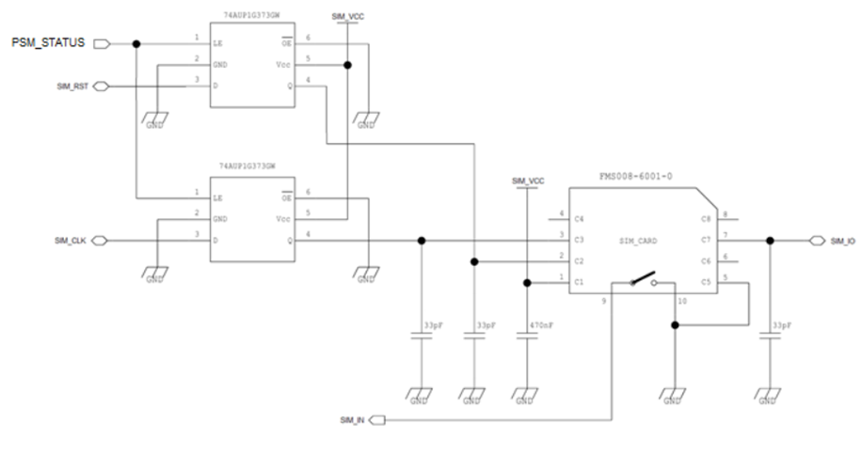

Figure 7‑1 PSM Status